**Scammell lorries**

Scammell was established in 1919, pioneering the concept of articulated vehicles when their first “artic” pulled eight tons up a steep London hill. When they introduced their Six-Wheeler, fifty orders were made immediately at the 1921 Motor Show, and because of this a new factory was built in Tolpits Lane in 1922. Scammell produced highly innovative designs that had a large number of uses. In 1929 for example, they launched the world’s largest truck, a 100-ton heavy tractor.

The outbreak of World War II saw an increase in the scale, quantity and variety of their products: silent-approach marine vehicles, fire-pumps, gun tractors, tank transporters, and Pioneer heavy recovery vehicles all made a massive contribution to the war effort. Scammell continued to produce their range of trucks and tractors until their closure in 1988.

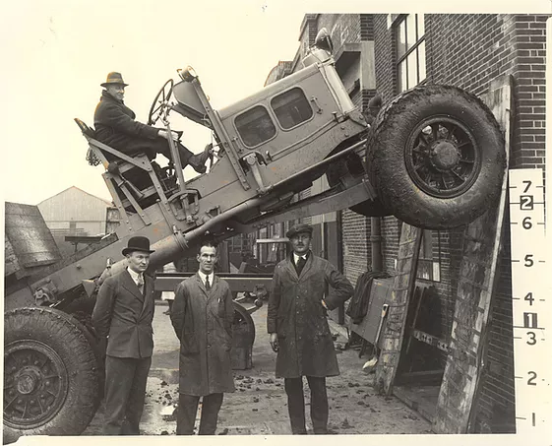

Scammell factory ( Mr Pugh, designer of the Scammell Pioneer driving himself up the wall in 1929)

For more photos see <https://www.watfordmuseum.org.uk/copy-of-royal-visits-to-watford-10>