Anglo Saxon Watford
A hoard of six Anglo Saxon coins were found in 1980 in Whippendell Woods dating from 915-930AD between the reigns of King Edward the Elder and King Aethelstan. They were classed as treasure trove and have been split between us and the British Museum. The four at the Museum are currently on display upstairs. There is no evidence of an Anglo-Saxon Settlement in Watford so these would have likely been lost or buried.

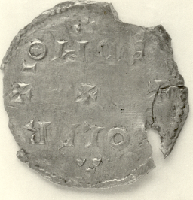

The Influence of St Alban

In the Roman city of Verulamium lived a citizen called Alban, who sheltered a Christian priest and was put to death in his stead, thus becoming the first Christian martyr in Britain. The event has pinpointed to 22nd June, 209 and as Christianity spread an important shrine grew up on the site of his execution. This waned under the influence of Anglo-Saxon paganism, but legend says that in 793 King Offa of the Mercians was resting in Bath when he was ordered by an angel to disinter Alban and place his relics in a shrine more worthy of them.
Whatever the reason, Offa found a Benedictine monastery in St Albans in 793, and followed the custom of financing its upkeep by making it a grant of lands and estates in Hertfordshire and elsewhere. One such grant of land was at Cashio, and thus began the link between St Albans and the community later to be known as Watford.

