World War One

Britain went to war against Germany on Tuesday, August 4, 1914. The day before had been a Bank Holiday and most Watford people had enjoyed an extra day off work – nobody seemed to be thinking about events unfolding in Europe. To most people in Britain in 1914, the First World War was seen as just another war, so when the ‘Call to Arms’ came, many local men signed up. Watford men were already serving in the Hertfordshire Regiment but as soon as war broke out, there was a massive recruitment campaign.

The effect of the war on the town was immediate. The food shops found people were buying more than usual and their stocks were running low. Troops began to arrive from other regiments and were billeted in people's houses, and church halls were opened so they had somewhere to relax in the evenings. Voluntary groups were involved in preparing supplies for use in military hospitals – foremost amongst these were the women of the Voluntary Aid Detachment (V.A.D.). However, the football season continued for 1914/15, before the league was suspended.

The Hertfordshire Yeomanry was mobilised on the outbreak of war in August 1914, and saw service in Egypt, Gallipoli and the Middle East, before some units ended the war in India. Few families were unaffected by the Great war. Conscription was introduced in 1916.

The first Watford man to be killed is believed to have been Private Frederick James Sanders from 10 Oxhey Street, who died fighting with the Royal West Kent Regiment at Mons on August 23, 1914, and other casualties were soon to follow.

Others left behind in Watford were involved in war work, the most spectacular of which was, perhaps, in munitions. Two factories were operated on behalf of the Ministry of Munitions, one on Imperial War and one at Greycaines, and these made mortar bombs, grenades, smoke canisters and small arms magazines. The work was dangerous and this was highlighted by a serious fire on 13th February 1917. Four members of the Watford Urban District Council Fire Brigade – Superintendent Pratchett, Motor Driver Robinson, Fireman Fountain and Fireman Wide – received the British Empire medal for their courage and devotion to duty in putting out this fire, and Mr Robinson’s medal has been given to the museum.

Many homes still treasure the tins which were sent to members of the armed forces from the Royal Family, holding chocolate, cigarettes and other luxuries to relieve the drabness of life in the trenches. At home, rationing was introduced in 1918 and some of the books have survived.

Women Munitions Workers World War I 1st Battalion Herts Regiment
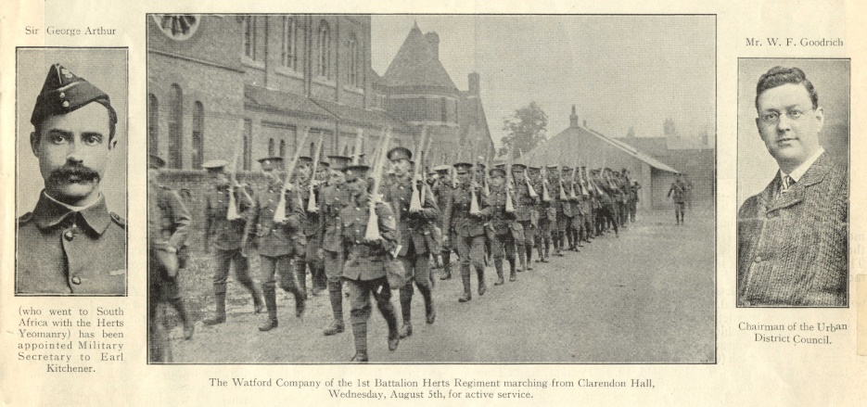
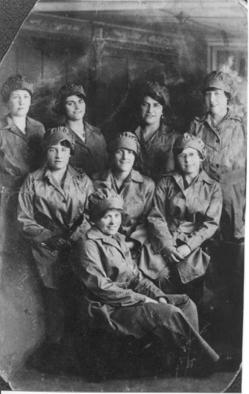

To commemorate the centenary of WW1, Watford Museum created a digital Roll of Honour: First World War: Roll of Honour Online | Our Watford History

Watford FC and World War One
George Badenoch, who played for Watford FC for three seasons between 1903-1906, was killed during the First World War while serving with the First Battalion, Canadian Infantry (Western Ontario Regiment). He had gone on to play for Tottenham Hotspur and Northampton Town after Watford, before emigrating to Canada. A medal was presented to Badenoch when Watford FC won the Southern League Division II Championship in 1903/04.

That medal is now part of the Watford Museum collection, having being donated by Watford FC fan Paul Barrie, who brought it back from a trip to Canada on behalf of Avril Barrie and Rob Bartholomew of Scarborough, Ontario, Canada.

By the time war ended on November 11, 1918, 12 Watford first-team players had served in the war: George Badenoch, Harold Bulling, Jimmy Chalmers, Albert Green, Owen Gregory, Ernie Grimsdell, Bill Hastings, Bill Markland, Robert McGuire, Joe McLauchlan, Alex Stewart and Skilly Williams.

Claude Buxton
Claude came to Watford in 1919 after serving as an ambulance driver in WW1. Although Watford’s black history goes back over 300 years Claude became the patriarch of the town’s first black family.
You can read more about his story here Retracing my father's footsteps | The Boxing Buxtons | Our Watford History

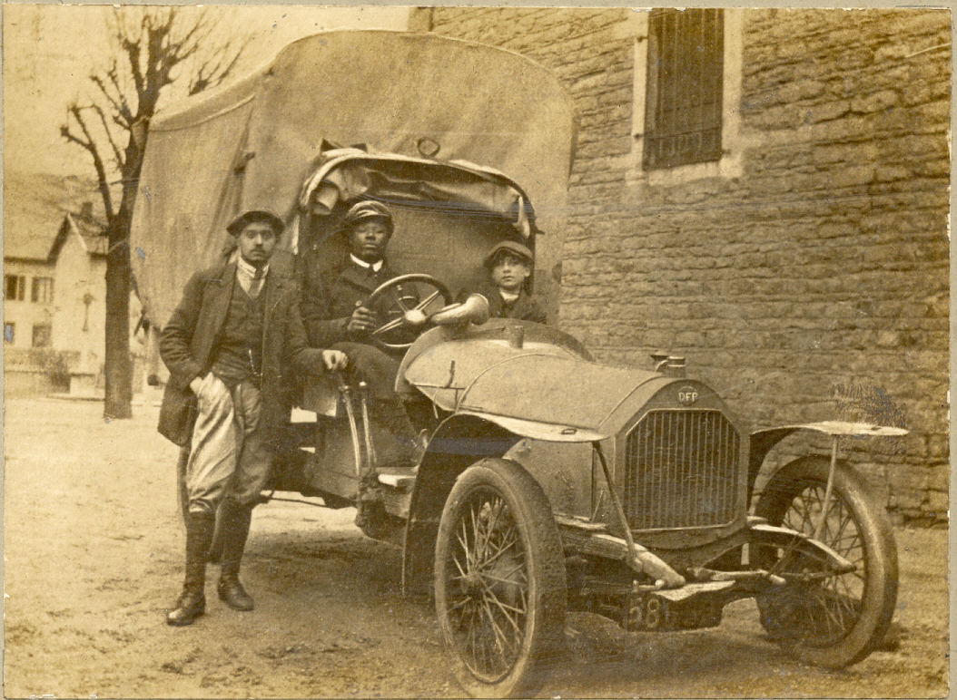

Claude driving an ambulance in World War 1

