Queen Adelaide

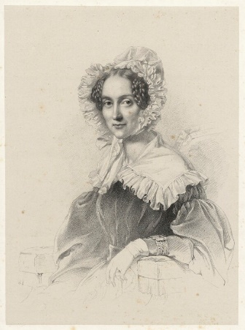
Photograph courtesy of the National Portrait Gallery

Adelaide was the daughter of George, Duke of Saxe-Meiningen and Louisa Eleanora of Hohenlohe-Langenburg. She was a German princess and married William in 1818. Adelaide took the title Duchess of Clarence.

Adelaide became queen consort when William became king in 1830. She was interested in the rights of children. She was also a supporter of the abolition of slavery in England.
When William died in 1837 and was replaced by his niece Victoria, who would remain on the throne until 1901.
She rented out Cassiobury from 6th Earl of Essex and lived there from 1846-8.
Victoria and Albert visited Cassiobury when Dowager Queen Adelaide lived there. The royal visitors used Watford’s first station house which still stands on St Albans Road. The station was used as a royal station for the royal visitors and was even remodelled with a royal waiting room!
Watford station closed in 1858 when Watford Junction opened but part of the Grade II listed building still survives.

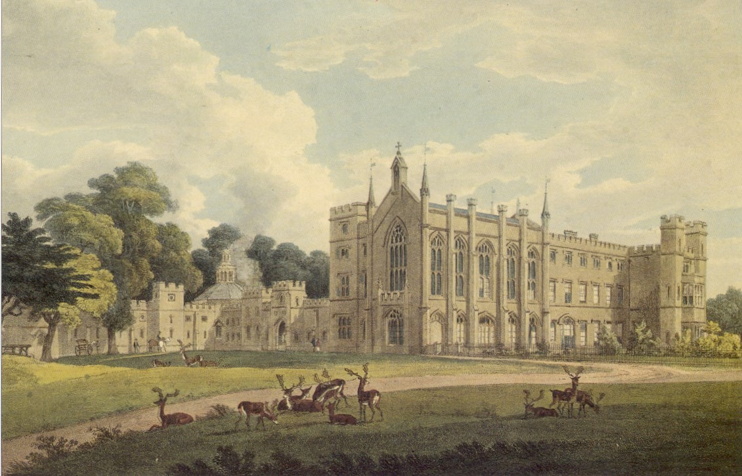
Cassiobury

