Watford Museum

Ludo

The board game Ludo is based on a traditional Indian

cross and circle game called Pachisi.

Pachisi was invented in the 6th century.

To play Ludo, players roll the dice in turns and race their

four tokens from the start to the finish.

This game was popular in the Carribean and in Sweden

and was known as ‘Ludi’ and ‘Fia’.

Why not have a go at making your own Ludo board and counters?

Watford Museum

Tin Cars

Tin cars were very cheap toys.

Tin is a type of metal.

Tin toys were stronger and lasted longer than wooden toys,

which made them a popular gift.

Tin can be painted with bright colours and decorations.

What colour and patterns would you decorate your car with?

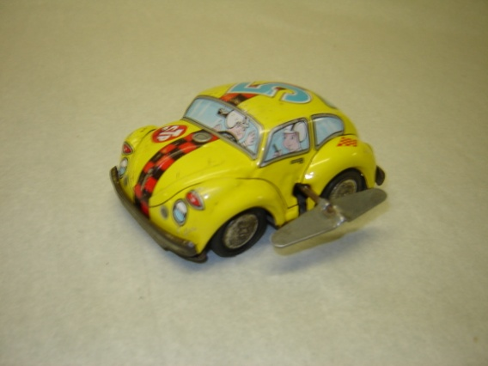

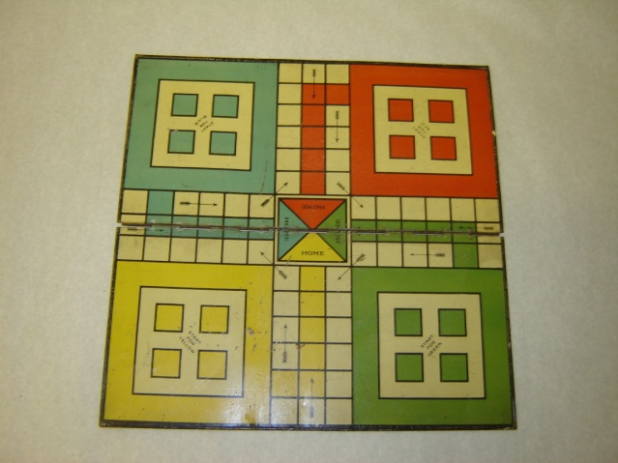

Watford Museum

Lott’s Building Bricks

In the early 1900’s, E. A. Lott created bricks that looked

like stone for children to build houses, churches, bus stations

and other buildings.

Arnold Mitchell taught Lott how to cut the bricks into

shapes that would be good for building.

Before Lotts bricks, German toy maker Richter and his Anchor

blocks were popular in Britain.

During World War One, restrictions stopped German toys

entering Britain, allowing Lott’s bricks to become popular.

Lott’s building blocks started selling in 1918, and they stopped being made in the 1960s.

What buildings can you make with Lott’s blocks? Can you make a town with your friends?

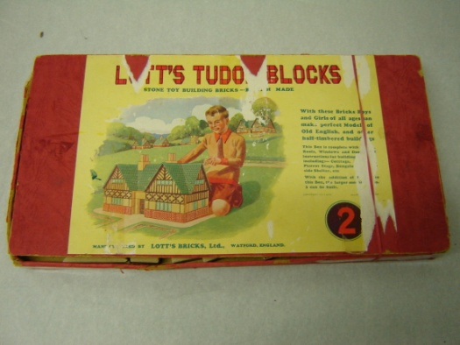

Watford Museum

Spinning Top

The spinning top is one of the world’s oldest toys. The earliest

example was found in the ancient City of Ur,

near Baghdad, Iraq in 3500BC.

Spinning tops were also used by the Greeks, Romans and Egyptians.

Spinning tops have been made from many different materials,

including clay, wood and metal.

You can make your own Spinning tops from cardboard and wooden skewers, why not have a go?

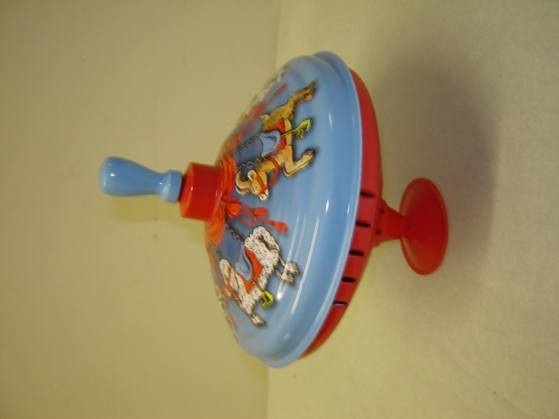

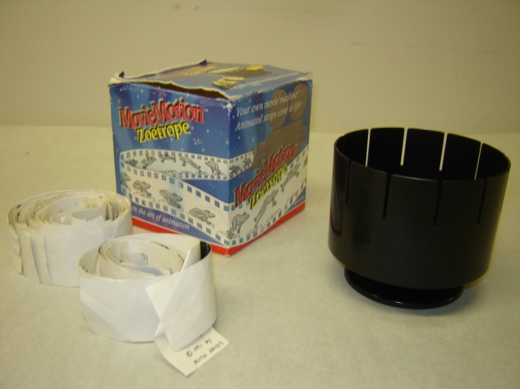

Watford Museum

Zoetrope

The first zoetrope was created in China around 180AD

by Ting Huan.

The modern zoetrope was invented in 1833 by

William George Homer.

The zoetrope is a device that produces an illusion

of a moving picture.

Have a look through the slits when the zoetrope is spun,

can you see the pictures on the strip move?

Have a go at designing your own picture strips for the Zoetrope. You could try using photography. Have a look at the work of Eadweard Muybridge for ideas.

Watford Museum

Wooden Alphabet Blocks

These were originally developed in the

17th century in England.

In 1693 philosopher John Locke stated that

‘dice and playthings, with letters on them to teach

children the alphabet by playing’, would make

learning to read a more enjoyable experience.

Many schools and nurseries still have wooden alphabet

blocks to help children learn to read.

What is the longest word you can make with the alphabet blocks?

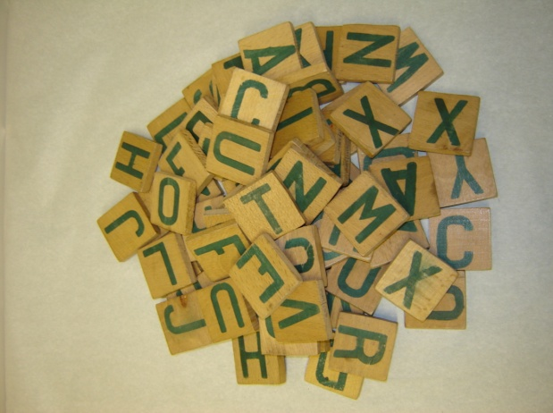

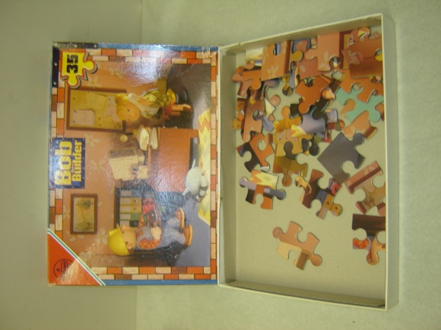

Watford Museum

Jigsaw

The jigsaw got its name from the device that was used

to cut it out, i.e a jigsaw.

John Spilsbury commercialised the jigsaw puzzle around 1760.

Spilsbury was a mapmaker. He used the jigsaw to teach

Aristocratic children geography.

He cut out the countries in the world map

and the children had to put them back in the right places.

In the 1900s, the wooden jigsaw puzzle also became popular with adults.

Why not have a go at making your own World map puzzle. Do you know where all the countries go?

Watford Museum

Cup and Ball Toy

The cup and ball toy was first made in 16th century France

and was a toy played with by King Henry III of France.

It became popular in England during Queen Elizabeth I’s

reign and was given its name ‘Cup and Ball’.

It is also known as ‘Balero’ in Latin American countries.

The cup and ball toy takes lots of concentration. How many times can you get the ball in the cup in one minute?

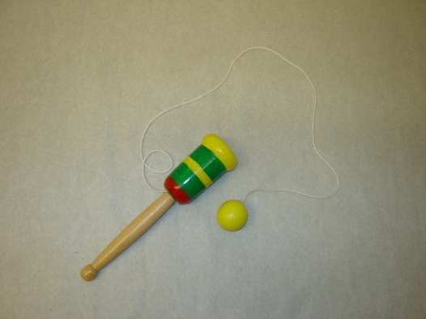

Watford Museum

Teddy Bear

The teddy bear was invented in November 1902. President Theodore ‘teddy’

Roosevelt failed to kill a bear when hunting in Mississippi. The hunting party

caught a bear for him and tied it to a tree, but Roosevelt refused to kill it

because he thought it was unsportsmanlike. Clifford Berryman drew a cartoon

of the scene and it was published in the Washington Post.

Inspired by the story, Brooklyn shopkeepers Morris and Rose Michtom made

a soft bear toy, which they named ‘Teddy’s bear’ and displayed it in their window.

America fell in love with the bear and it became the president’s mascot.

Around the same time, Margarate Steiff, a disabled German seamstress with

a soft toy factory also created a soft plush bear. She sold 3,000 in America in 1903.

People that collect teddy bears are called ‘arctophiles’.

The teddy bear celebrated its 100th birthday in 2002.

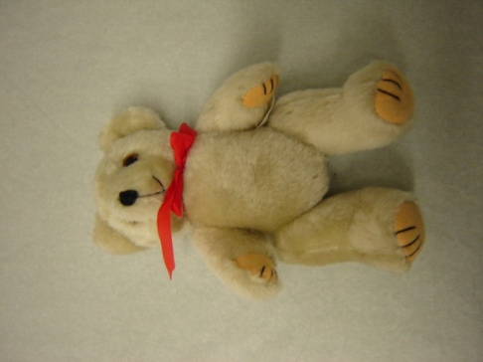

Watford Museum

Wooden Whistle

The whistle is an ancient instrument, likely to have come from

China 5000 years ago. The whistle came to Europe in the

11th century.

Whistles can be made from wood or tin. In the early 19th

Century, English whistles began to be made with the

six finger hole arrangement. Wooden whistles were very popular

with Victorian children.

Can you play a tune on the whistle?

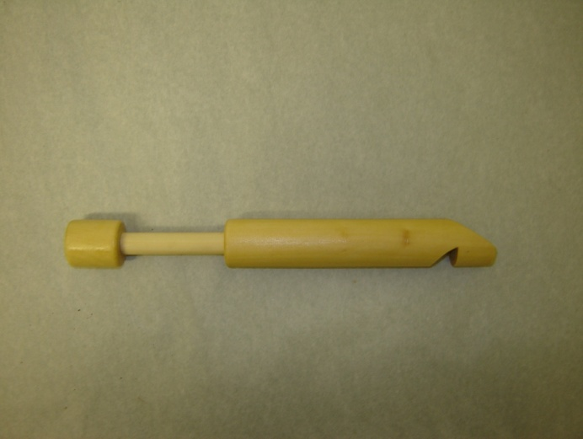

Watford Museum

Sunny Jim

Sunny Jim is the name of a character that was used to sell

Force breakfast cereal.

Force was first made in 1901 in the USA. It was one of the

first wheat-based breakfast cereal brands.

It soon became a popular cereal in Britain and people could

collect Force tokens and send money to receive a Sunny

Jim Doll. These dolls were popular in the 1960s.

Have a go at designing your own cereal.

What would you use as your mascot?

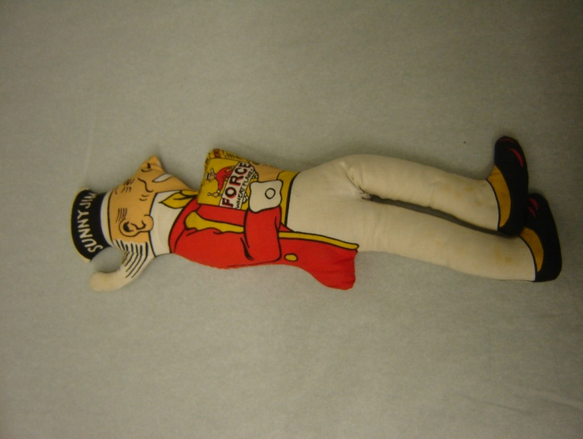

Watford Museum

Meccano

Meccano was invented in 1898 by Frank Hornby.

It was based on his creation of nuts, bolts and parts

for his two sons to build cranes, like the ones that

they would see at the Liverpool port.

Meccano can still be bought today to build all kinds

of models and mechanical devices, from cars to planes.

What will you try and make from the Meccano?

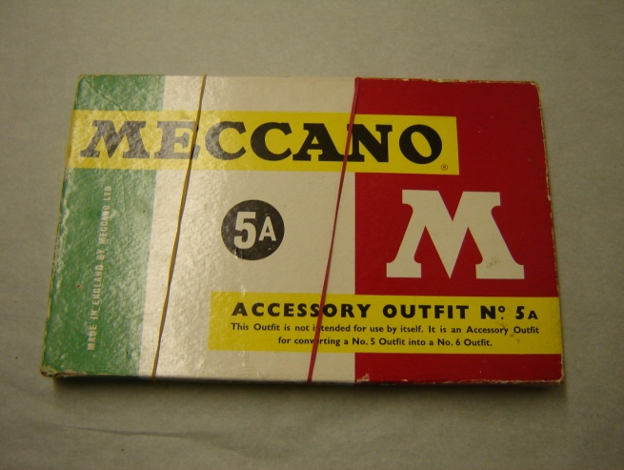

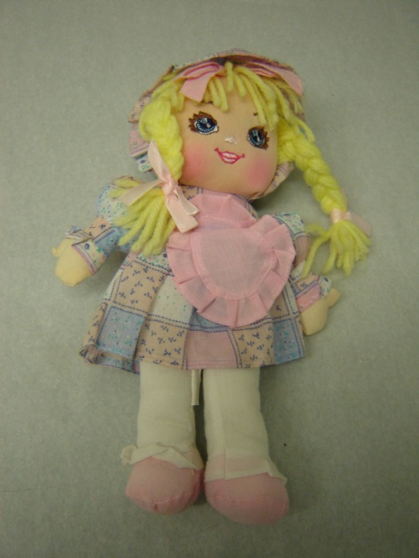

Watford Museum

Doll

Dolls have been around for many years. In 200BC, Ancient Egypt

had flat wooden dolls with hair made out of string or clay.

In the 19th century dolls were made out of porcelain, which is

a type of ceramic. The Victorians that owned the dolls thought

that porcelain looked like skin because it was thin and

slightly transparent.

The doll in the box is like a rag doll. Rag dolls were made by

mothers for their children. In the 1850s, they began to be

made commercially in England and America. A rag doll

is normally made out of cloth like linen or cotton.

Often a rag doll was a child’s first toy. What was your first toy?

Useful Websites on Toys

Make your own Spinning Top

<http://www.koolkidscrafts.com/spinning-tops.html>

Zoetrope History

<http://zoetrope.org/zoetrope-history>

<http://www.earlycinema.com/technology/zoetrope.html>

Alphabet blocks

<http://www.toyhalloffame.org/toys/alphabet-blocks>

Childhood through time

<https://www.bbc.co.uk/bitesize/topics/zc9s6g8>

The Historian’s Toybox – Make Your Own Toys

<http://www.arvindguptatoys.com/arvindgupta/toybox.pdf>

Children’s games in the 20th century

<http://www.mccord-museum.qc.ca/scripts/explore.php?Lang=1&tableid=11&tablename=theme&elementid=44__true&contentlong>