Violet Cressy – Marcks

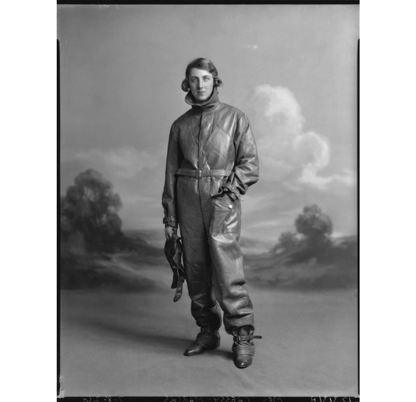

Photograph courtesy of the National Portrait Gallery

Violet Cressy – Marcks (1895–1970) was an explorer. She went round the world many times. It is said she travelled to every country in the world by a variety of means! These travels including crossing the Arctic by sledge and navigating the Amazon by foot and canoe. She took the first motor transport from Addis Ababa to Nairobi and also visited the Ethiopian and Eritrean war fronts taking cine films.

Violet was from a wealthy family. Her second marriage was to Watford butcher Francis Fisher. She lived at Hazelwood Hall (now Hunton Park)
She usually travelled alone. She was interested in topics including archaeology, zoology, ethnology and geography.

She wrote only two books about her journeys. In the first, Up the Amazon and Over the Andes (1932) she wrote, 'A snake crawling over one at night is… not a pleasant proposition… The wretched thing had bitten me below the knee…' Having lanced the wound, she found a mirror 'to see if I was going black or grey… I decided on coffee, a walk and sleep, and if I was going to die… I was at peace with the world - so … there was nothing to worry about'.
In Northwest China in 1937 she interviewed Mao for five hours at the remote cave dwellings that housed the wartime Communist Headquarters.

In 1938 she was a war reporter in Chungking (Chongqing) for the Daily Express, as she recorded in Journey into China (1940).

