**Medieval Watford information sheet**

In the 12th Century a market was granted to the Abbot of St. Albans as lord of the Manor, which continued until 1928. The original market charter is lost so we do not know the exact date.

The one street (the High Street) was established and grew during this period. It was approximately a mile in length. The market was set up as a livestock market on Tuesday and for general goods on Saturday. The market was the meeting place of the town.

The Abbot also arranged for the first church to be built adjacent to the market, St. Mary’s. Little remains of medieval Watford apart from St Mary’s Church, the earliest domestic buildings to survive are the Bedford Almshouses built in 1580.

In the Peasants revolt in 1381 there was a reference to Cassio Mill. This was connected to the compulsory use of the Abbot of St Albans mill, one of the grievances in the revolt.

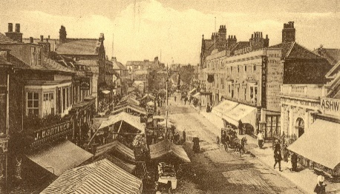

A later picture of the market Source Watford Museum