The Pond in Watford
This was a natural feature in Watford. In Victorian times people used to give their horses and livestock water here on market days. The south end sloped to provide access. Today it is a lovely place to walk. There are many more photos of the pond at https://www.watfordmuseum.org.uk/photo-collections

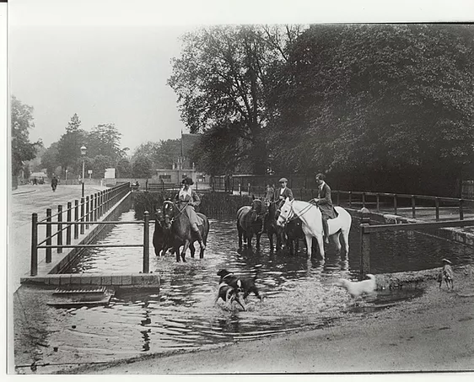 | 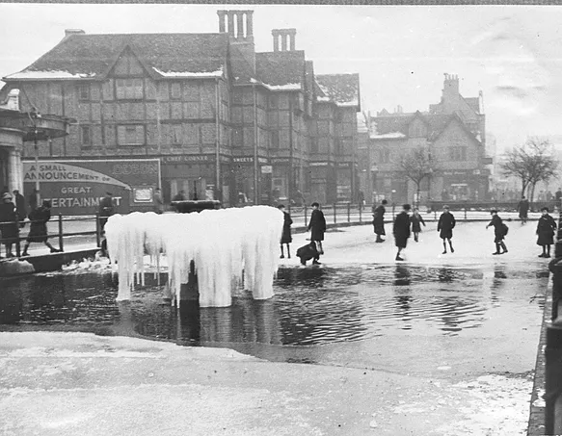 | 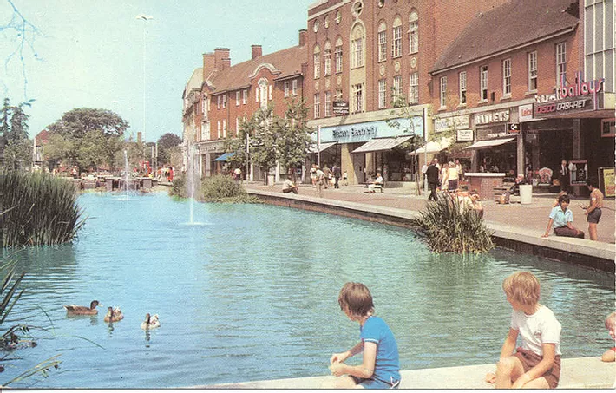 | 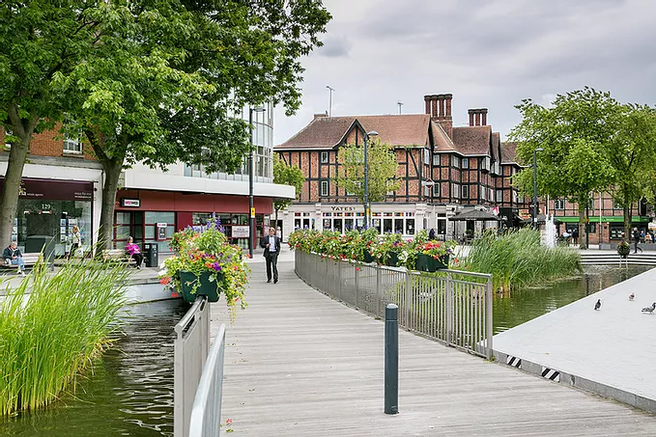
The Pond 1920s | Skating on the Pond 1945 | The Pond 1974 | The Pond today

