**The railways in Watford information sheet**

The London and Birmingham Railway opened on 20 July 1837 and ran between Euston and Boxmoor. In 1837 the town’s first railway station was opened on its then site at the bridge in St. Albans Road. The station had first- and second-class waiting rooms, departure yard, carriage shed, engine house and facilities for pumping water. In 1843 even Queen Victoria and Prince Albert took the train from Watford Station.

On 5 May 1858 the branch line to St. Albans was opened to passengers, bringing with it a need for a bigger station. Therefore, a new station was opened to the south of the St. Albans Road railway bridge, as the original station north to the bridge had been abandoned. The old ticket office stands near the bridge on the west side of St. Albans Road. There were three platforms with general waiting sheds and separate rooms for ladies and gentlemen. The station meant many new buildings and houses were constructed. In 1881 Watford provided a commuter service; an hourly train from Euston. This station was demolished in 1909 that was necessary for the planned electric trains from Euston to Watford. In 1984, the building was demolished again, to make room for an office block, accommodation for a booking office, travel centre and waiting area.

The second branch that served Watford was the Watford and Rickmansworth railway which opened 1 October 1862. This new line became the suburban electric services which ran from Euston and Broad Street to Watford. This electric line went between the Junction and High Street stations before heading in the direction of Bushey. In 1875 thriving industries and the rapid growth of the population meant that extensions to the station were necessary. Four lines were now in use and goods sheds, sidings and a double tunnel were all constructed. On 10 February 1913 the new line was opened for steam services and included the new branch of Croxley Green which opened on 15 June 1912.

The Metropolitan Railway was the world’s first underground line, opened in 1863 to ease traffic congestion and to provide a link between Paddington, Euston and Kings Cross. From the late 1860’s onwards the line began to expand throughout the northern suburbs, the company gaining profits from the development of commuter housing in these areas. The final railway which reached Watford was the Metropolitan branch which opened on 2 November 1925 near Cassiobury Park. The station is one of four ‘Metroland’ stations built by Charles Clark during the Metropolitan Railway’s great inter-war extension phase in an Arts and Crafts style. The line was poorly used in comparison to Watford’s other stations due to its distance from the centre of the town and therefore a regular bus service had to be introduced to and from the High Street station for a penny.

On the branch from Watford to St. Albans there were a number of intermediate stations. Callowland, which opened in October 1910 and later became Watford North in March 1927. Garston opened much later in 1966 to serve new housing and industrial growth. Bricket Wood, Park Street and Frogmore were the next stations on the line and opened in August 1858. The terminus of the Branch was St. Albans Abbey Station.

In the early 1950’s the steam as a method of railway power was disappearing, to make way for diesel engines which were closely followed by the complete electrification of the railways. This method had only been seen in the London Electric Railway’s Underground trains that ran directly to Watford.

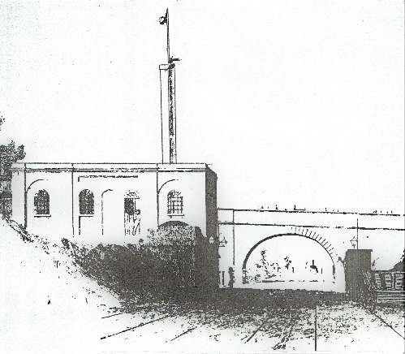

First Watford station –between London and Birmingham

.