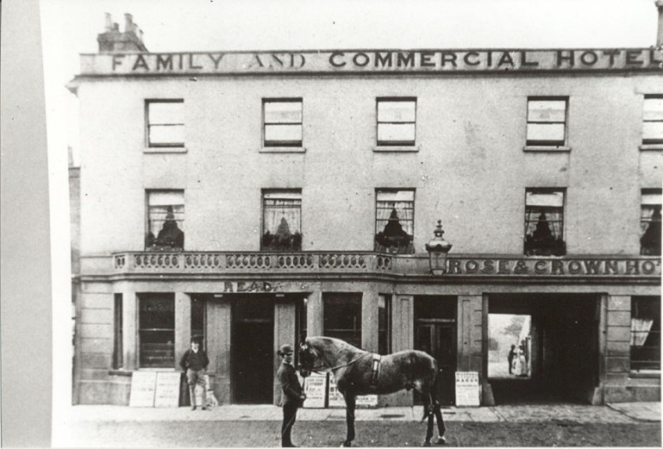

Behind the bar we have a Victorian cash register and the Cox Patent Till from the Saracen’s Head Pub, Kings Langley. Cox used the till to register patents in 1883 and 1893. To prevent complaints of wrong change, Cox invented this till to keep money from the previous three or four transactions separate from each other. You can see on its right side that money was pushed along the horizontal shelves.

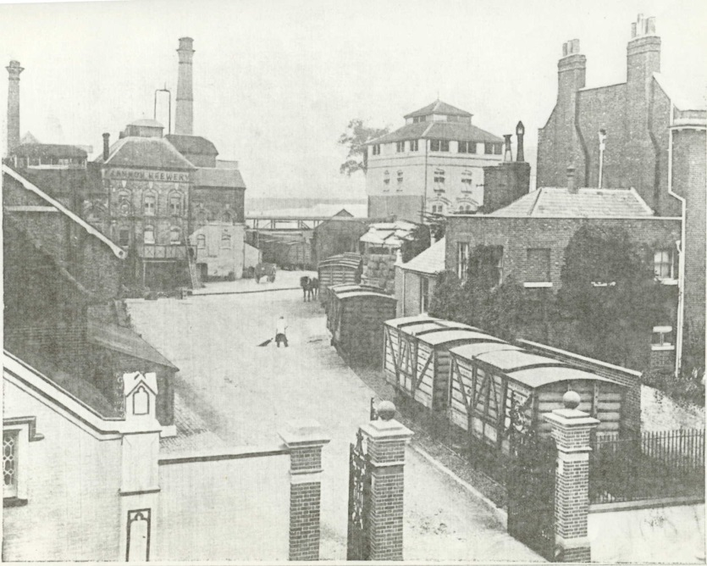

Joseph Benskin purchased the building that is now Watford Museum in 1867 for his family home. After Joseph’s death, the building was converted into two homes, one for his wife and the other for his daughter Maria and her husband Walter Green. Walter was the Head-brewer at Benskin’s at the time. You can still see the differences between the homes if you look closely at our ceilings.

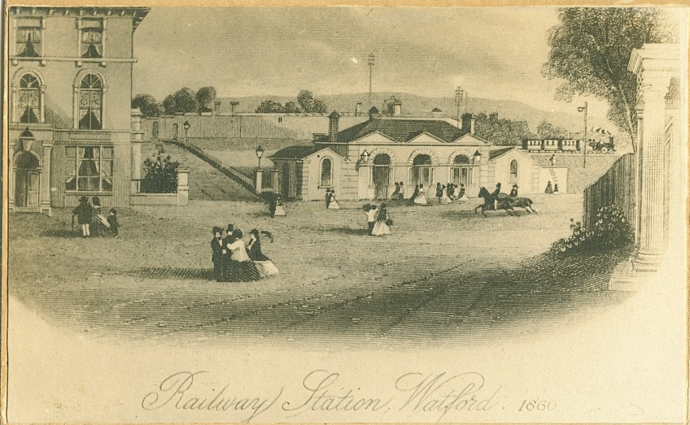

The railways had a big impact on Watford. Victoria became queen in 1837 – the same year the railways came to Watford. Before the railroads, Watford had a population of less than 3,000. By the time Queen Victoria died in 1901, Watford’s population had grown to nearly 30,000!

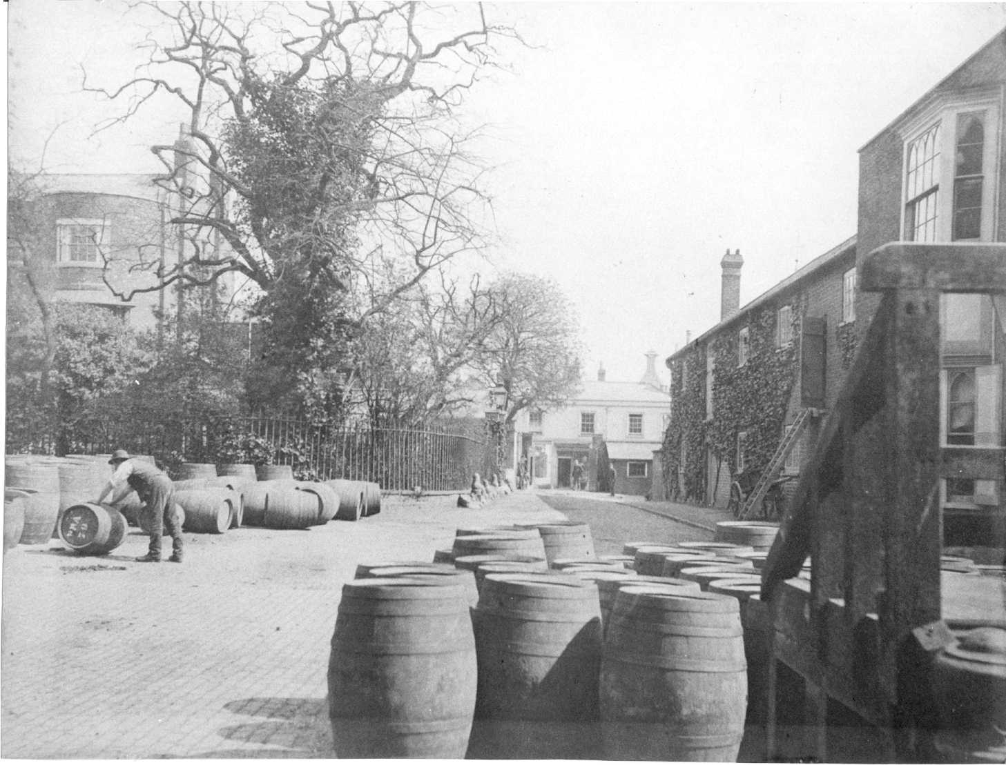

Brewing on this site dates back to 1750. Many brewers came to Watford for fresher water, necessary for brewing. By the end of the Victorian era, Benskin’s Brewery was putting out over 3,000 barrels of beer a week.

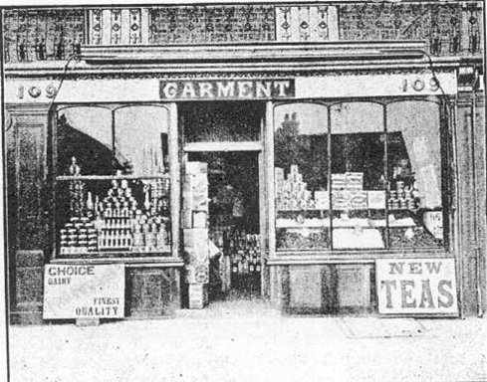

Printing was an important industry in Watford and still exists today. Without the internet, newspapers were used to share information during the Victorian times. Machinery helped to make printing more efficient. The Colombian Press was used to print the first Watford Observer in 1863.

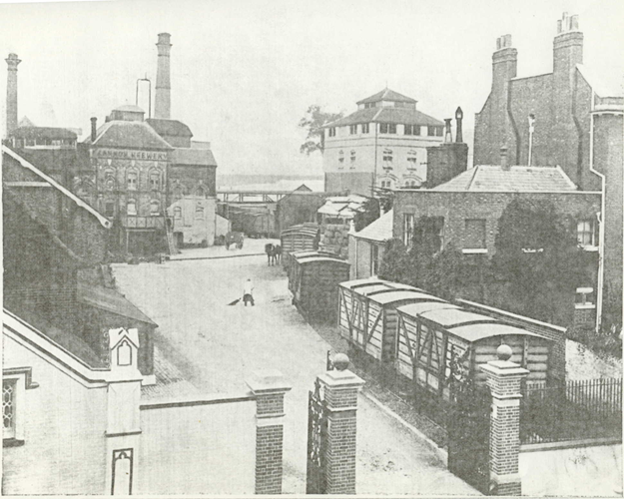

After the Victorian era, Benskin’s Brewery used this building as offices until the brewery was closed down in the 1950’s. This is why the Benskin’s logo is still on our window today.

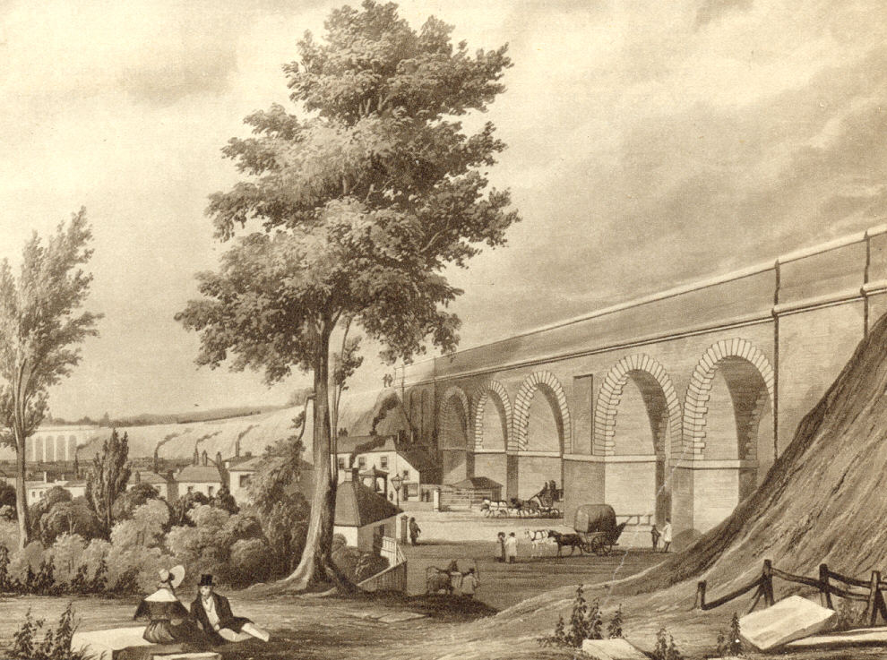

The Bushey Arches bridge was designed by Robert Stephenson and built between 1834 and 1837 for the London-Birmingham Railway. Originally, it was only two lines. At one point, the railway was the longest in the world at 112.5 miles long.

Watford Junction station was built when a third London-Birmingham line was built in 1858. The Earls of Essex and Clarendon, who lived in Cassiobury and The Grove, did not want the railway going through their land so it was rerouted.

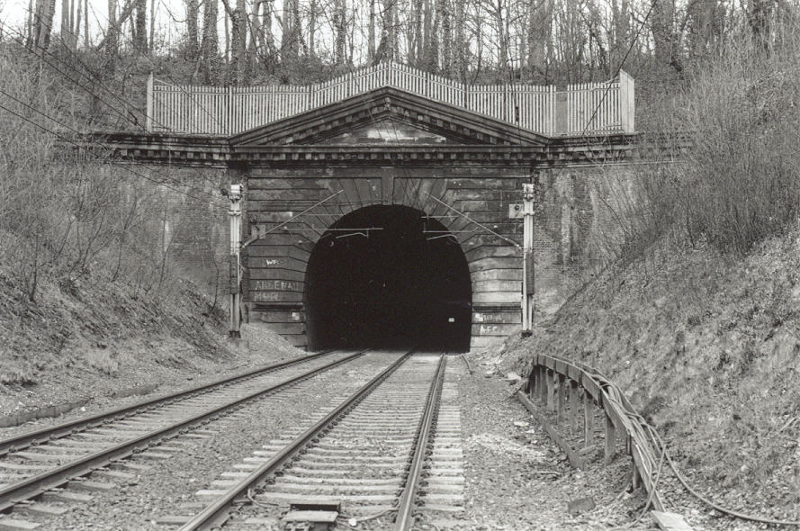

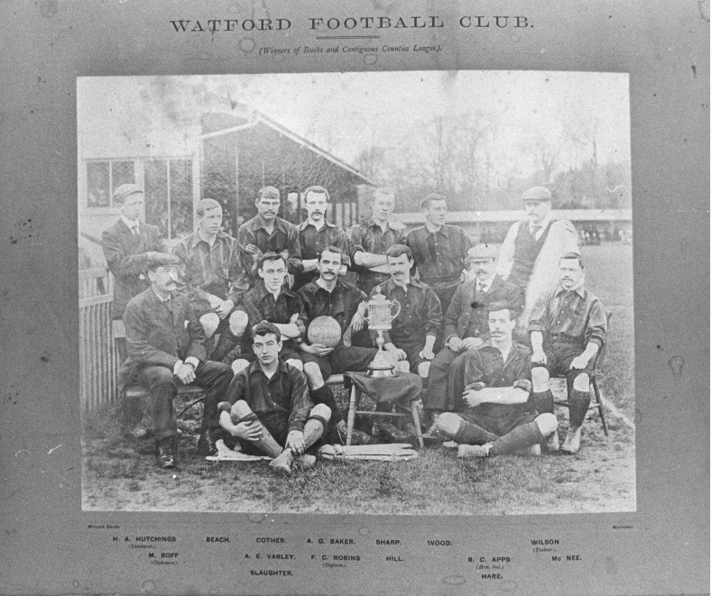

Even Watford football has roots in the Victorian era. The first FA recognised football team was the Hertfordshire Rangers in 1866. In 1881 the Watford Rovers were formed and in 1898 the name finally became Watford FC.

P:\Watford Museum\Images\High Street - house numbers may not be as they are today\Market Place high street 1800s.TIF

Watford High Street station, just down the road from the Museum, was not built until 1862 for trains running between Watford and Rickmansworth.

Watford Field School was one of the ‘Board Schools’ built in 1891 was one of the many schools built in Watford after the Local School Board evolved in 1883. It was so close to the brewery, that students could smell the brewing during their lessons.

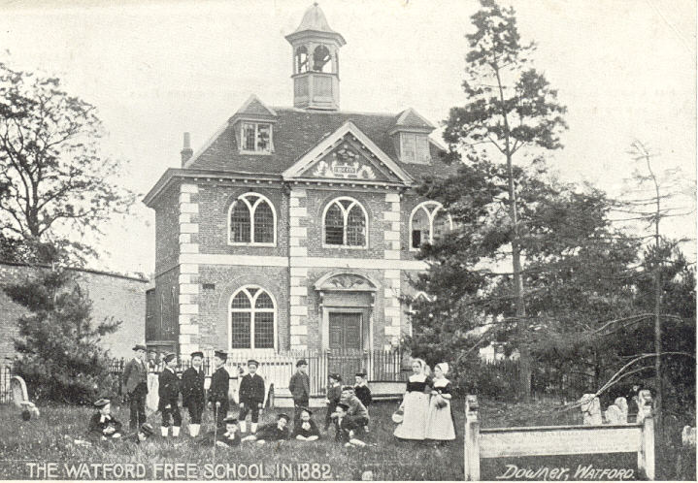

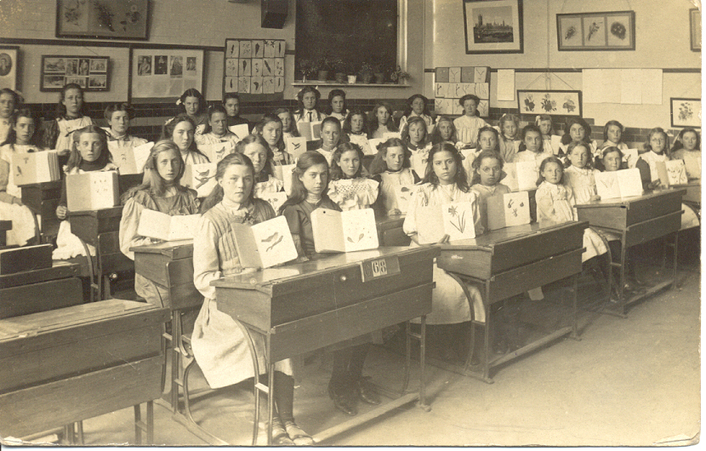

Attendance medals were given to children who came to school on time every day. They were used to incentivise attendance. At the beginning of each day, a bell was rung and the children would line up in order of height.