Significant People Involved in Printing
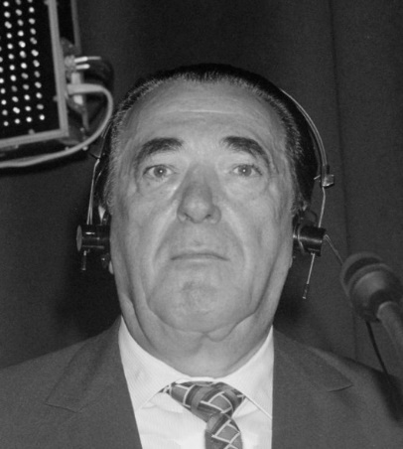
Robert Maxwell
He born on the 10th of June 1923 in Ukraine in poverty.
Maxwell fought in World War Two for the Czechoslovakian army
and was known as Captain Robert Maxwell. He died on the 11th of November 1991 (aged 68) after falling off his yacht near the Canary Island. He is buried in Israel. He was a media proprietor who owned the Mirror Group, among other companies
In 1981, he bought the Sun Engraving Company and changed its name to the British Printing and Communications Corporation. He also acquired Odhams two years later and merged it to become the Odhams- Sun Printers in 1983.He was the Labour MP for Buckingham in the 1960s
He had seven children.
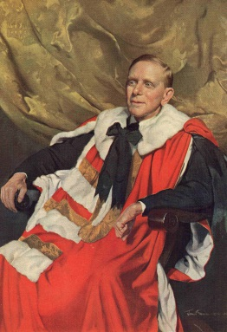
Viscount Southwood of Fernhurst
Julius Salter Elias was born on the 5th of January 1873 in Birmingham, England. He left school at 13 and joined the Odhams Bros Company. He was also a Labour peer as Baron Southwood from 1937 and then was appointed Chief Whip of the Labour Party in the House of Lords in 1944 He went on to become the head of Odhams Press Ltd .He married in 1906 and had no children.
He died from a heart attack on the 10th April 1946 at the age of 73

John Peacock
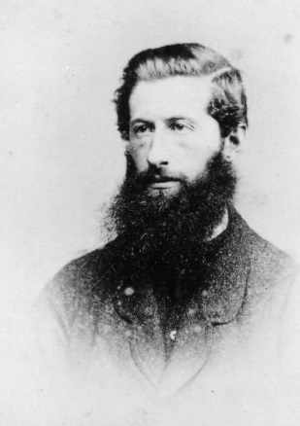
He was born in 1767.
He was a printer and bookbinder and set up a company where the High St. Station stands currently.His son was Samuel Alexander Peacock.One of the founders of the town’s printing industry in the early 19th Century. His grandson was Thomas John Peacock.In 1827, John Peacock applied for a license in the 1841 census when he was 60 years old.

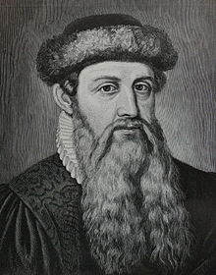
Guttenberg
His full name was: Johannes Gensfleisch Zur Laden Zum Gutenberg
He was born in Germany in approximately 1400.
He died in Germany on 3rd February 1468.
Created the first printing press in 1450.
Gutenberg printed the first Bible with 42 lines on each page. They cost 30 Florins (Italian coin) each.
Between 1450 and 1455, Gutenberg printed several texts
He was buried in a graveyard in Mainz, Germany but the graveyard and church was destroyed and so his grave is lost.

